5.12: If the rope makes an angle with the vertical, then 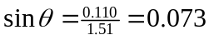 (the denominator is the sum of the length of the rope and the radius of the ball). The weight is then the tension times the cosine of this angle, or
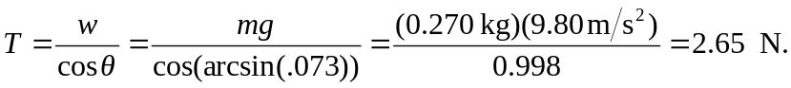
The force of the pole on the ball is the tension times 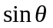, or 